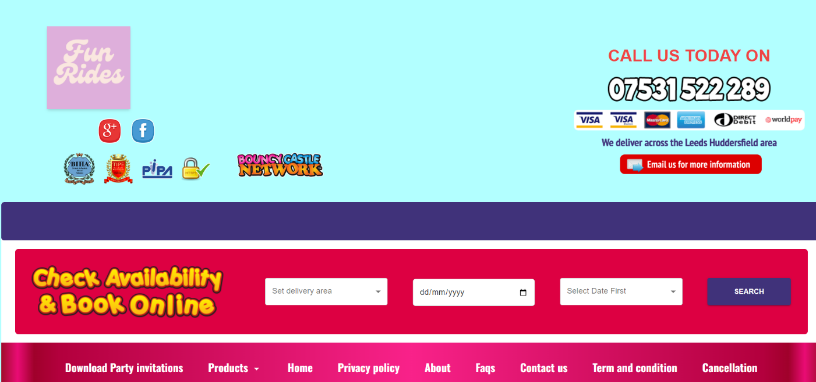

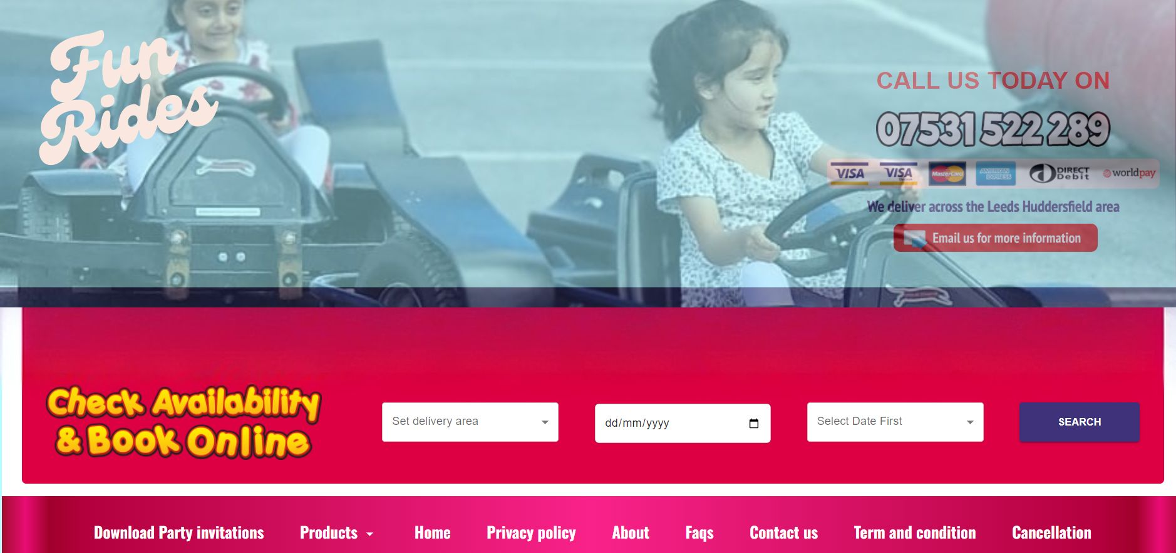

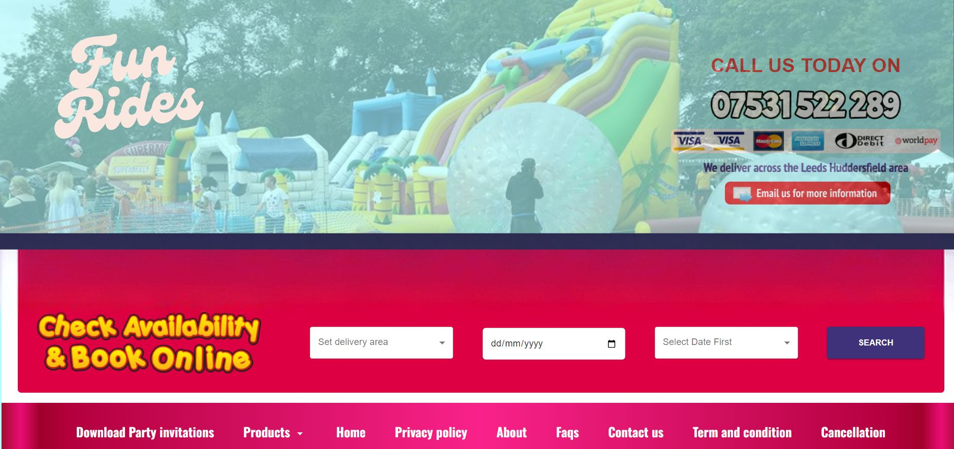

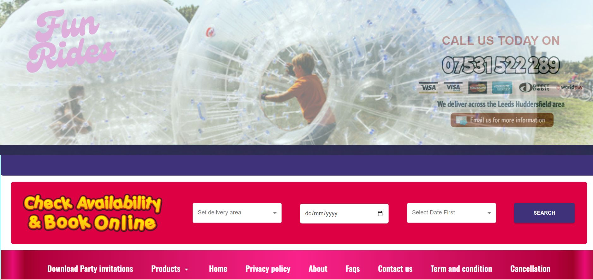

Text for Home page

Explore our fantastic selection of bouncy castles, slides, obstacle/assault courses, disco inflatables, and more, all available for hire online. In addition to our wide range of inflatables, we also offer exciting attractions for kids, including go-karting. Our services cater to all ages and events, featuring everything from bouncy castles and inflatable slides to adult bouncy castles, event packages, disco domes, and obstacle courses, ensuring there's something for every occasion and budget. With inflatables in various sizes, themes, and designs, we have something to delight everyone—princess castles for little royals, superhero inflatables for future heroes, and football-themed inflatables for avid fans. For young adventurers, our jungle-themed inflatables and dinosaur castles are a hit, while our disco domes provide the perfect setting for those who love to dance. We also participate in events across Leeds, Manchester, Dewsbury, and many other locations.

Thank you for visiting our website and we hope to be catering your event soon!

1. Make background white and put image on it – please use the image I have added now on one drive – do not want multiple moving images
2. Make transparency on image – done – thank you
3. Change font same as logo – as u said u did not find it I have uploaded the font into one drive for u
4. Change red color on menu (where it says check availability and book online) to same purple used on logo – not done it’s still red (the purple on the logo is more like lilac color)
5. Test For the Home page – not there still visible the old text from Fun Factor
6. Add the menu – Home, Products, Events, Privacy Policy, Contact Us, Terms & Conditions, Cancellations – Not added – still old menu can been seen fromn Fun Factor
7. Side menu – not changed

In addition the the above please also change the following

1)Change the color of the Logo purple

2) make the “call us today on 07xxx plus rest of the writing smaller and remove all the visa, mastercard etc images – also change we deliver text to “We deliver across West Yorkshire area”

3) remove the dark purple bar under the image on top

4) Under check availability you have the menu, change color for the menu bar to white and make the writing of the menu same as logo color (lilac/purple)

5) Under the menu bar place a “Search Products” bar where people can search for a product

5) Remove the images from under the menu and also the Featured Products section and images.

6) When you add the text for home menu, I want a few images to be placed in that text. I selected the images and uploaded them on one drive for you to use.

7) Remove “discover our amazing products”

8) The Side menu should also Start right under the search bar (Home, Products, Events, Privacy Policy) and on its side to be the text with images. (please check <https://www.premiuminflatables.co.uk/> for reference)

9) Remove all the boxes with products next to the side menu – there will be the text with the images I provided to you

10) Remove all rights reserved and bouncy castle network at the end of the page